Project 2B | Infix & Postfix Notations

Design, implement and test a Java utility class, Notation, that will perform –
- Infix to postfix conversion (of an expression)
- Postfix to infix conversion
- Postfix evaluation
Infix notation is the notation commonly used in arithmetical and logical formulae and statements. It is characterized by the placement of operators between operands – "infixed operators" – such as the plus sign in "12 + 2".

Postfix notation is a notation for writing arithmetic expressions in which the operands appear before their operators. There are no precedence rules to learn, and parentheses are never needed.

Watch our weekly Video Notes and learn more about –
- Infix to postfix conversion
- Postfix to infix conversion
- Postfix evaluation

Academic Honesty Policy – Do your own work. Each project submission will be compared against other submissions from current and previous semesters.

Good Faith Attempt (GFA) Requirement – Your submission must successfully pass all of the provided (public) Junit test cases. In general, they are the xyz_test.java and xyz_GFA_test.java files (where xyz is the project name).

Expectations
- INCLUDE your name as the author on every Java file that you are creating
- Review this write-up, the provided Notations.html and Java interfaces
- I would then –
- Implement all of the required methods
- Create specified exceptions (just like Project 1)
- Test project against provided JUnit test cases
- Test project using the provide UI
- Anticipate (think about) the private test cases

Specifications
Data Element
- String

Data Structures
- NotationQueue, a generic queue, implements the provided QueueInterface
  - The Queue must be a linked list (nodes) implementation
- NotationStack, a generic stack, implements the provided StackInterface
  - The Stack must be a linked list (nodes) implementation
- Additional “helper or support” (private) methods may be implemented for these classes, should they be helpful

Utility (Notation) Class
- convertInfixToPostfix – Convert infix notation to postfix notation
- It will take in a string and return a string
- A queue should be used to hold the postfix solution. (Use the toString method of the Queue to return the solution as a string)
- convertPostfixToInfix – Convert postfix notation to infix notation
- It will take in a string and return a string
- evaluatePostfixExpression – Evaluate the postfix expression
- It will take in a string and return a double
- Leverage the NotationStack and/or NotationQueue to perform your calculations. For simplicity sake –
- Operands are single-digit numbers (integers)
  - 5 + 4 (for example)
- Supported arithmetic operations –
  - Addition (+)
  - Subtraction (-)
  - Multiplication (*)
  - Division (/)
  - Modulus (%)
- Bonus (10% of project grade) : Enhance your code to support double-digit numbers
  - 14 + 9
  - Do this last
  - You must discuss your bonus effort in your write-up

DO NOT utilize the Queue, Stack, Hashmap classes from the java.util package. Consult with your instructor first, if you are considering an Util class. Don’t copy and paste any similar classes from the Internet either. You need to implement all of the specified classes on your own.
The GUI
- Use the provided GUI to test your code
- Initially neither radio button for notation is selected. When a radio button is selected, the Convert button is enabled and the appropriate label and field are visible for the user input.
- When the user selects the Convert button, the appropriate label and field with the conversion will be displayed.
- When the user selects the Evaluate button, the “answer” to the expression will be displayed.
- When the Exit button is selected, the application will close
- The provided GUI should work as-is to support your testing. Even if it’s off by a little, you still can use it to test out your logics. Consult with your instructor first, if you are thinking about making changes to the GUI – there is no need to

- I will make UI updates accordingly as needed. Don’t spend too much time fixing any UI related code. The UI will work with the specified requirements
- Should you encounter any JavaFX import errors, check out the following article
  - https://www.chrisnewland.com/eclipse-cant-find-import-javafx-320
- You MUST fix all JavaFX errors so that you can test your project with the provided GUI
- If you did not complete CMSC 203 at MC or it has been a while since you took the course, you may need to download JavaFX
  - https://www.youtube.com/watch?v=oVn6_2KuYbM
  - https://gluonhq.com/products/javafx/

Exceptions
- Implement the following user defined exception classes:
- InvalidNotationFormatException – occurs when a Notation format is incorrect
- StackOverflowException – occurs when a push method is called on a full stack
- StackUnderflowException – occurs when a top or pop method is called on an empty stack
- QueueOverflowException – occurs when an enqueue method is called on a full queue
- QueueUnderflowException – occurs when a dequeue method is called on an empty queue

Testing and Student JUnit Test Cases
- Test cases and test results (See Project Rubric)
- Test your project with 4 other test cases (that you have created on your own) to ensure that your project is working correctly
- Capture your test runs (actual vs. expected results) in your write-up. It’s to demonstrate that that you have attempted to test your project. A 28% deduction will be imposed to any project that did not capture their test cases and respective test results in the write-up
- In addition, your project will be tested with an additional set of private test cases
- Testing is very important
- You should not need to modify any of the provided Java files other than the reference package name, such as package abc. Check with your instructor first, if needed
Programming Concepts
This project utilizes the following concepts:
- Generic Queue
- Generic Stack
- Infix and Postfix conversions
- Postfix evaluations
- Exception handling
- Previously covered topics

Write-up & Submission Requirements
Review the provided rubric to understand the project expectations, including documentation, CMSC204 and programming requirements. Each project submission MUST include your working Java code and a write-up. For Project 1, a sample write-up has been provided.

Your write-up, at a minimum, needs to address -
- Approach, design & algorithm
  - DO NOT start coding your project immediately! Come up with a high level design first. Complete this step first, then write your code
    - Break the project into smallest modules where applicable
  - Each student is welcome to expand on the design. If your project includes “above and beyond” features, clearly articulate them in your write-up. Potential extra credit could be earned if that is the case
- Test plan & test cases
  - What test cases did you run?
  - I want to understanding your “thinking,” and you need to be sure that your project works!
  - For each test case, specify the expected vs. actual outputs
  - Capture several test runs as screenshots, as you run your test cases
  - I will attempt to break your code (with reasonable test cases)
- Highlight your learning experience and lessons learned
  - I am very interested to learn about what you have done, how you did, etc.
- Discuss any additional enhancement
  - What did you do?
- Any assumptions that you are making for this project
- Anything else that you want to share

Each student must submit one compressed (.zip) file back to the Assignment (link) with the following:
- Source code (.java files)
- Write-up (a Word or PDF file)
- Name your compressed file as <lastname>_project_x
  - where x is the project number and your last name (e.g., Thai_Project_1.zip)
- Review provided instructions on how to submit the project carefully (don’t assume anything)
- I can only grade what’s being submitted. Double check your submission
- I MUST BE able to compile, run and test every submitted project on my computer using a set of test cases. Just as important, I will READ your write-up first

Not clear? That’s okay, but do ask your questions. “I did not know” or “I did not understand” is not good enough.

Start working on each project immediately so that we can discuss any concerns or questions you have.

Sample Test Cases & Outputs (Consider them as examples only)

These are sample test runs. They are provided to enhance your “understanding” of the project. Your actual runs may be different.
- Don’t overlook these test cases – we are doing integer arithmetic
  - 5 + 4 * 30
  - 5 / 4 // result should be 1.0; NOT 1.25 because we are doing integer division
  - 15 / 0
  - 15 + + 3
  - What private test cases might your instructor be thinking about?

At startup
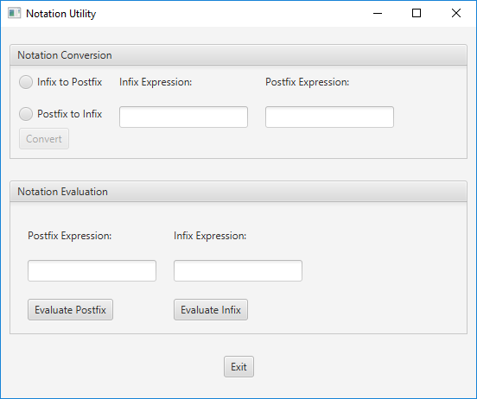

After selecting Infix to Postfix
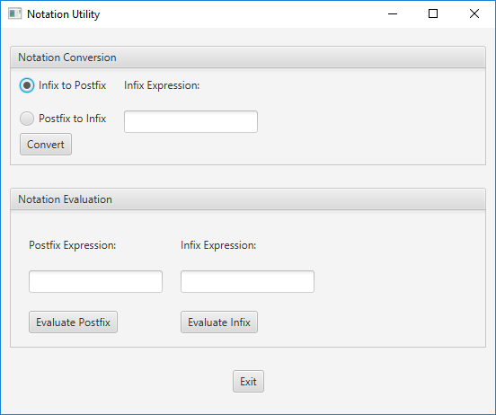

After selecting Postfix to Infix
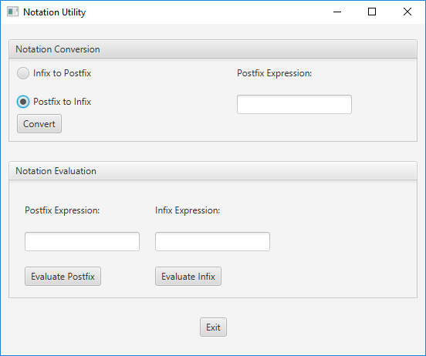

After selecting Convert Button
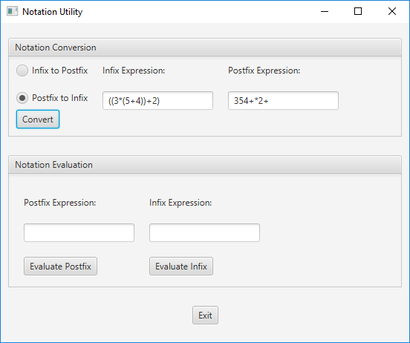

After Evaluate Postfix and fix buttons

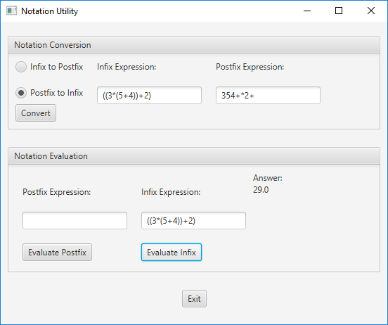
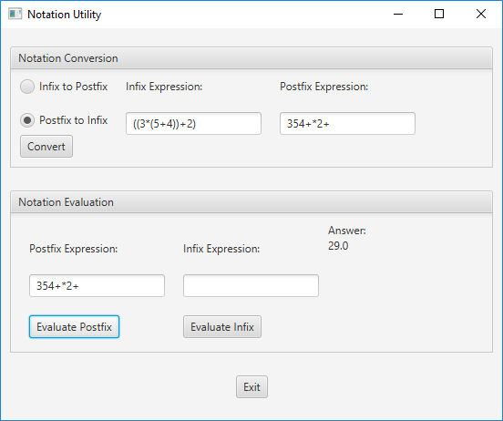

Don’t forget to think about those private test cases that your instructor will be testing your project against.

